DEVS UAV Control System

SYSC-5807

Assignment 1

Rami Youssef

St # 100204490

Part I

General Description

The System under consideration is an Unmanned Aerial Vehicle (UAV) hierarchical control system. It has the following structure

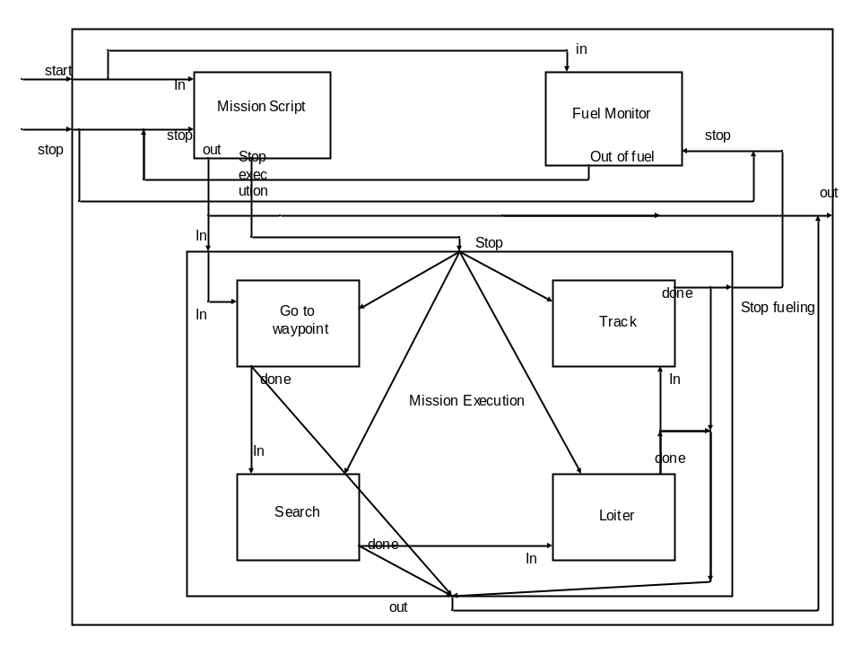

The System contains the following components
- Mission Script: responsible for starting the mission
- Fuel monitor: responsible for checking the fuel level and taking appropriate measures when the fuel goes below a certain value
- Mission Execution: responsible for carrying the missions, and this component contains four other components as follows:
  - Go To WayPoint
  - Search
  - Loiter
  - Track

Brief Specifications

- Mission Script: The state of this component is either active or passive. The state variable is the preparation time, which defines when a state goes from active to passive
- Mission Script: The state of this component is either active or passive. The state variable is the preparation time, which defines when a state goes from active to passive

- Go to Waypoint: The state of this component is either active or passive. The state variable is the estimated arrival time, which defines when the UAV will reach the destination and therefore, when a state goes from active to passive
- Search: The state of this component is either active or passive. The state variable is the search time, which defines how long the UAV search the area and therefore, when a state goes from active to passive
- Loiter: The state of this component is either active or passive. The state variable is the search time, which defines how long the UAV Loiter over a target and therefore, when a state goes from active to passive
- Track: The state of this component is either active or passive. The state variable is the track time, which defines how long the UAV track the target and therefore, when a state goes from active to passive

Part II

Coupled Models Formal Specifications

Top: <X, Y, D, {M_{i}}, {Ii}, {Z_{ij}}, select> where:

X = { Start, Stop}
Y = out
D = index for the components of the coupled model
{M_{i}}= set of basic models
{Ii} = set of influencees
{Z_{ij}}= set of translation functions
Select = tie breaker

Mission Execution: <X, Y, D, {M_{i}}, {Ii}, {Z_{ij}}, select> where:

X = {In, Stop}
Y = {Out, Stop Fueling}
D = index for the components of the coupled model
{M_{i}}= set of basic models
{Ii} = set of influencees
{Z_{ij}}= set of translation functions
Select = tie breaker

Atomic Models Formal Specifications

Mission Script : <S, X, Y, δ_{int}, δ_{ext}, λ, ta > where:

S = {Active, passive}
X = {In, Stop} where in = start
Y = {out, Stop execution}
δ_{int} = Internal transition Function
passivate()
δ_{ext} = external transition Function
if( msg.port() == in )
{
if( !elements.empty() )
{}
else
{
elements.push_back(1) ;
holdIn( active, preparationTime );
}
}

if( msg.port() == stop )
{
if( elements.empty() || elements.size() ==2 )
{}

else{
elements.push_back(0) ;
holdIn( active, preparationTime );
}

λ= Output Function
ta= time advance function

Go To Waypoint : <S, X, Y, δ_{int}, δ_{ext}, λ, ta > where:

S = {Active, passive}
X = {In, Stop}
Y = {done}
δ_{int} = Internal transition Function
passivate()
δ_{ext} = external transition Function

if( msg.port() == in )
{
holdIn( active, estimatedArrivalTime );
}

if( msg.port() == stop )
{
if( state() == active )
{
passivate();
}
}
λ= Output Function
ta= time advance function

Search : <S, X, Y, δ_{int}, δ_{ext}, λ, ta > where:

S = {Active, passive}
X = {In, Stop}
Y = {done}
δ_{int} = Internal transition Function
passivate()
δ_{ext} = external transition Function

if( msg.port() == in )
{

holdIn( active, searchTime );
}

if( msg.port() == stop )
{
if( state() == active )
{
passivate();
}
}

λ= Output Function
ta= time advance function

Loiter : <S, X, Y, δ_{int}, δ_{ext}, λ, ta > where:

S = {Active, passive}
X = {In, Stop}
Y = {done}
δ_{int} = Internal transition Function
passivate()
δ_{ext} = external transition Function

if( msg.port() == in )
{
//elements.push_back( msg.value() ) ;
//if( elements.size() == 1 )
holdIn( active, LoiterTime );
}

if( msg.port() == stop )
{
if( state() == active )
{
passivate();
}
}

λ= Output Function
ta= time advance function

Track : <S, X, Y, δ_{int}, δ_{ext}, λ, ta > where:

S = {Active, passive}
X = {In, Stop}
Y = {done}
δ_{int} = Internal transition Function
passivate()
δ_{ext} = external transition Function

if( msg.port() == in )
{
holdIn( active, TrackTime );
}

else if( msg.port() == stop )
{
if( state() == active )
{
passivate();
}
}
λ= Output Function
ta= time advance function

Fuel Monitor : <S, X, Y, δ_{int}, δ_{ext}, λ, ta > where:

S = {Active, passive}
X = {In, Stop}
Y = {out of fuel}
δ_{int} = Internal transition Function
δ_{ext} = external transition Function

if( msg.port() == in )
{
if(!elements.empty())
{}
else
{
elements.push_back(1) ;
holdIn( active, fuelCapacity);
}

}

else if( msg.port() == stop )
{

if( elements.empty() || elements.size() ==2 )
{}
else
{
if( state() == active )
{
passivate();
}
}
}

λ= Output Function
ta= time advance function

Testing Strategies
Each component can be tested separately by providing the different possible input. However, there are some restrictions that were put on the whole system, which can not be tested in every atomic model. For example: the system will not accept 2 sequential start events. However, some of the atomic model such as the Search model will not enforce this restriction if run separately, but the whole system will enforce this restriction. Testing the whole system is more rigorous, and in fact it can be tested by providing a variation of the input events with different parameters. In fact, the system was tested, and under all tests, it behaves exactly as expected.

Part III

Conclusion
The System was tested several times with different inputs, and under all tests, it behaved correctly. Therefore, one can conclude that DEVS is a very good replacement for FSM, and in fact it solves some of FSM limitations. Therefore, it could be used as a substitute to express FSM models.

Read Me

In order to run the model, first it has to be compiled using the make command in the cygwin window, then in the DOS window, run demoo.

In order to check the status, open the controller.txt to see the propagation of messages.
In order to test different scenarios, just change the input event in the .EV file.

